The hydraulic rams are for moving the floor up and down and the racks and pinions are to keep the floor level across the entire diameter. Without the racks the rams with the least friction would rise first significantly tipping the floor with severe consequences.

There has been talk over the years about lowering the floor of the 36 inch telescope to the level of the lower outer floor ring. This would facilitate easy wheelchair access and movement of staging and people onto and off of the floor. The idea is to make a small section of rack to fit in the area where teeth have been removed. The teeth have been removed in these areas for floor leveling. If there is too much weight on the floor or the weight is distributed unevenly the pinions may skip a tooth or two resulting in an unleveled floor.

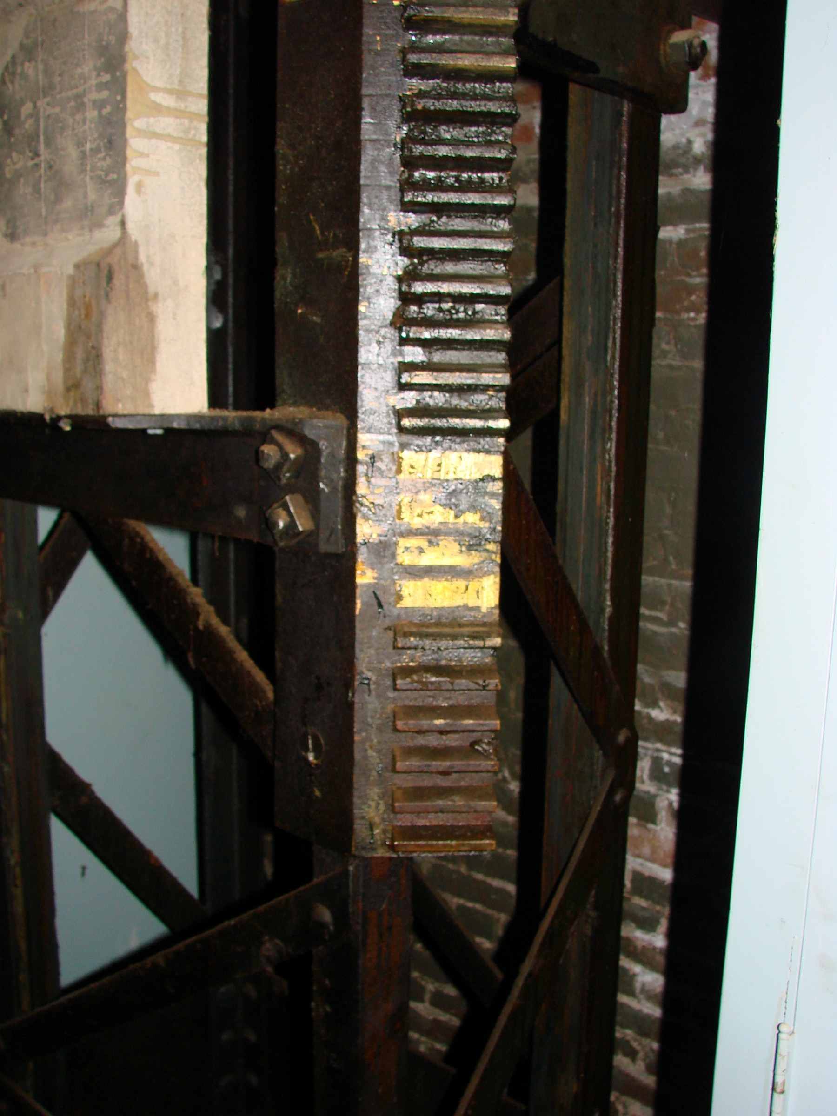

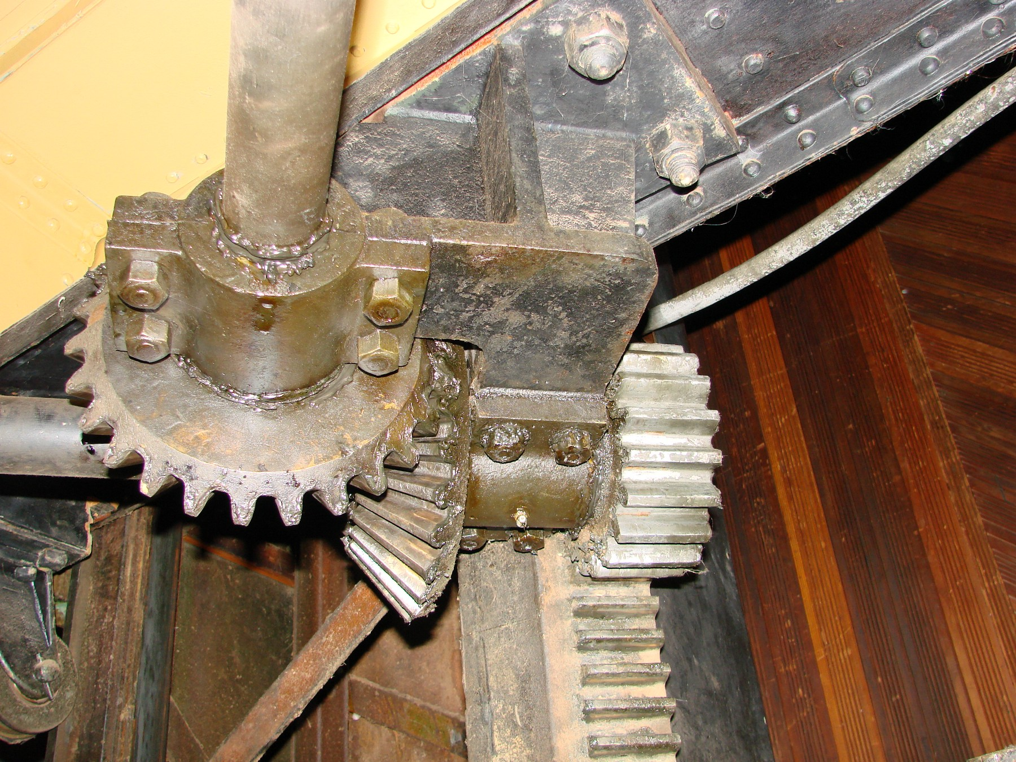
These are the leveling gears that ride on the racks.

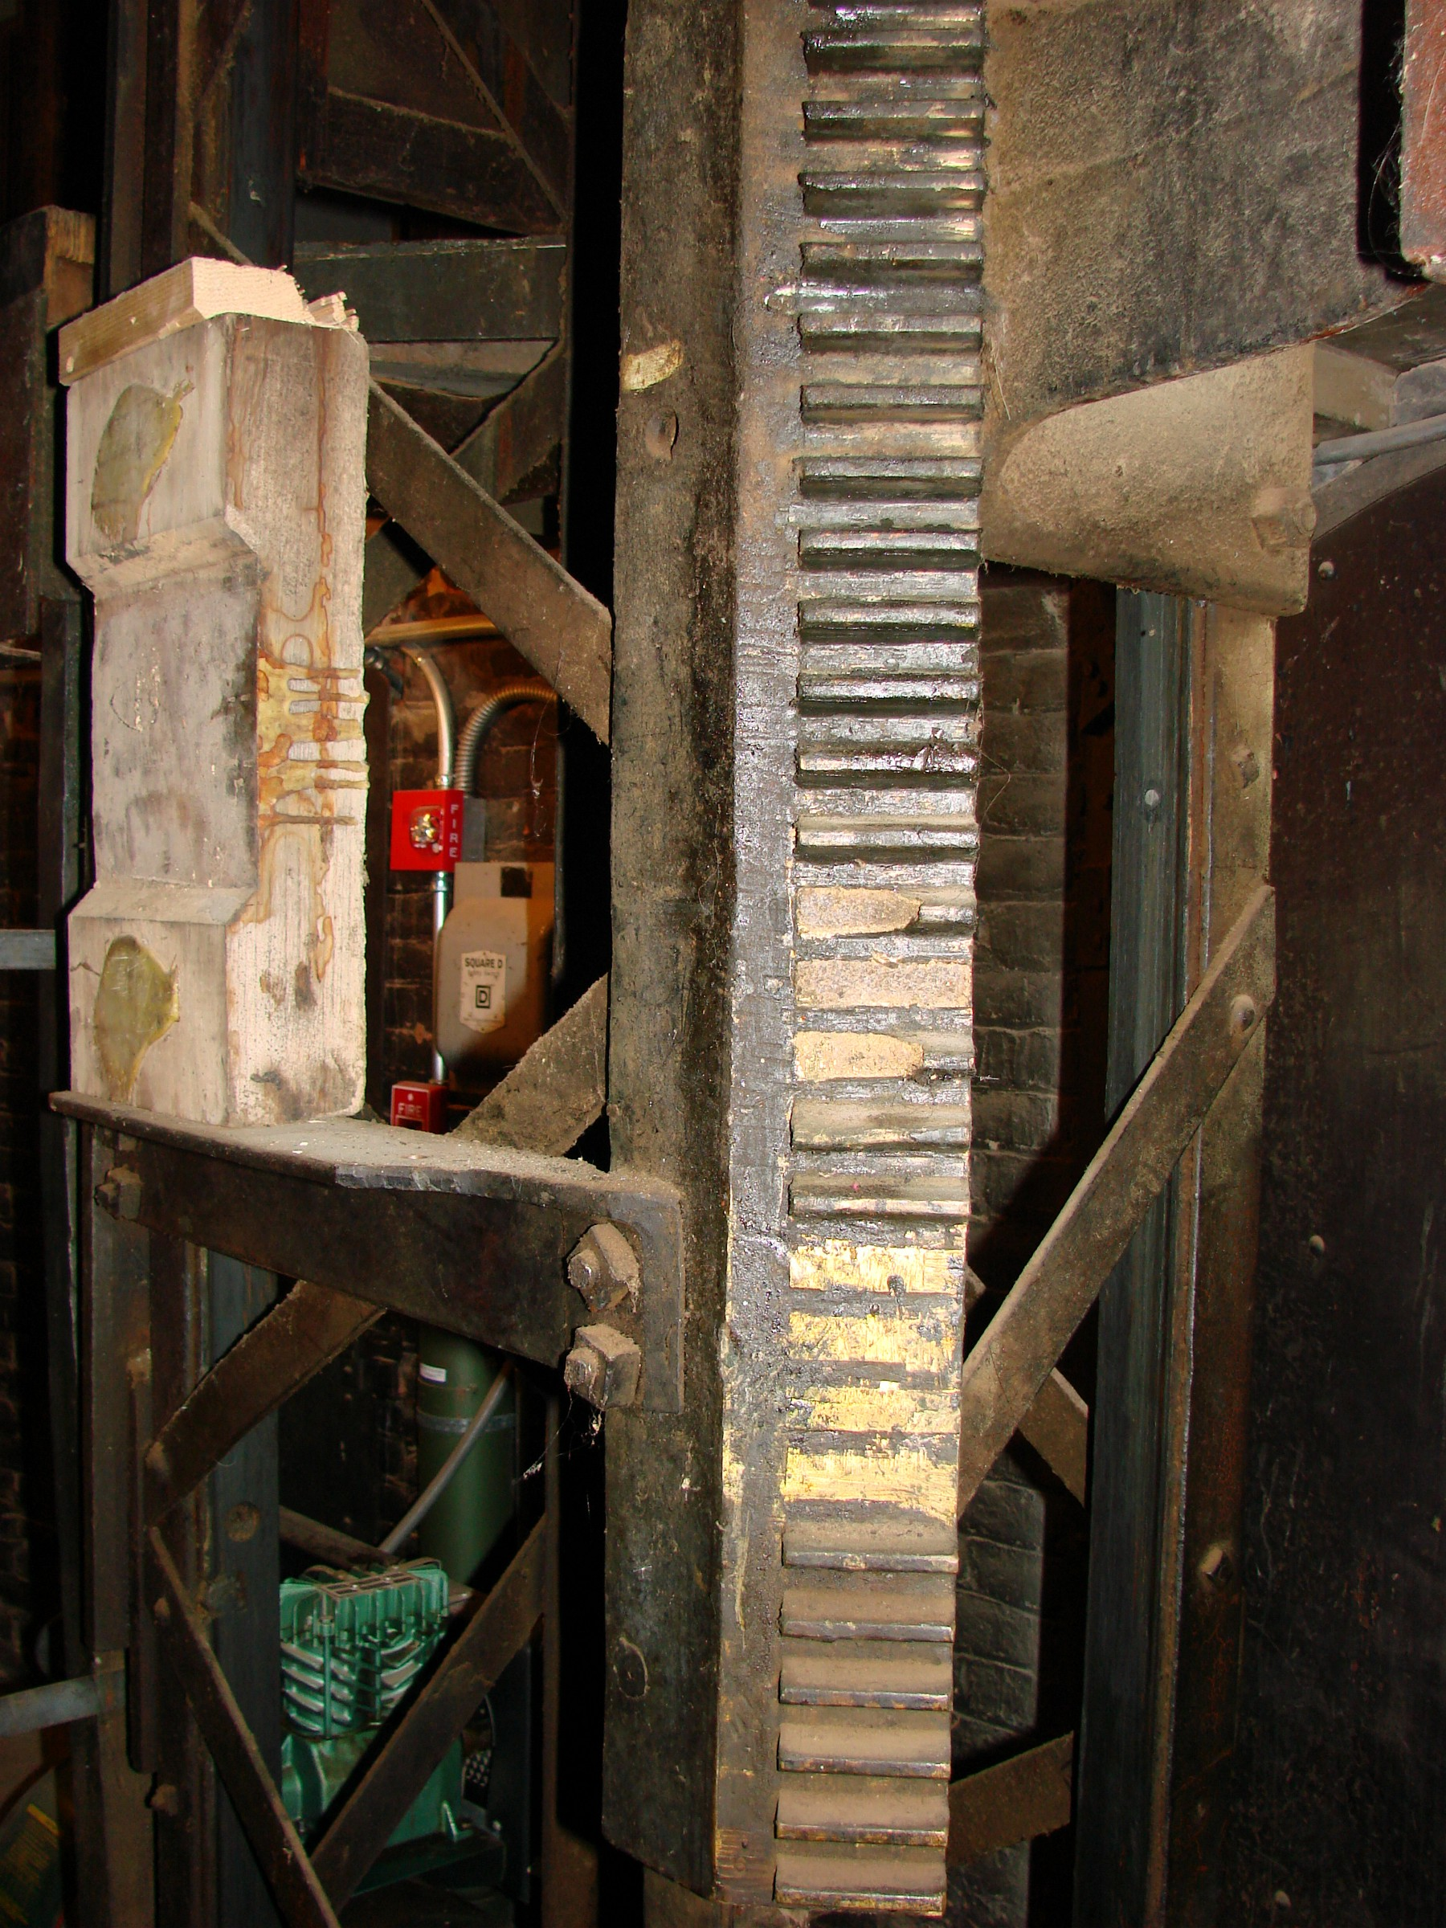
Here on this rack some upper teeth have broken out above the floor leveling section.

